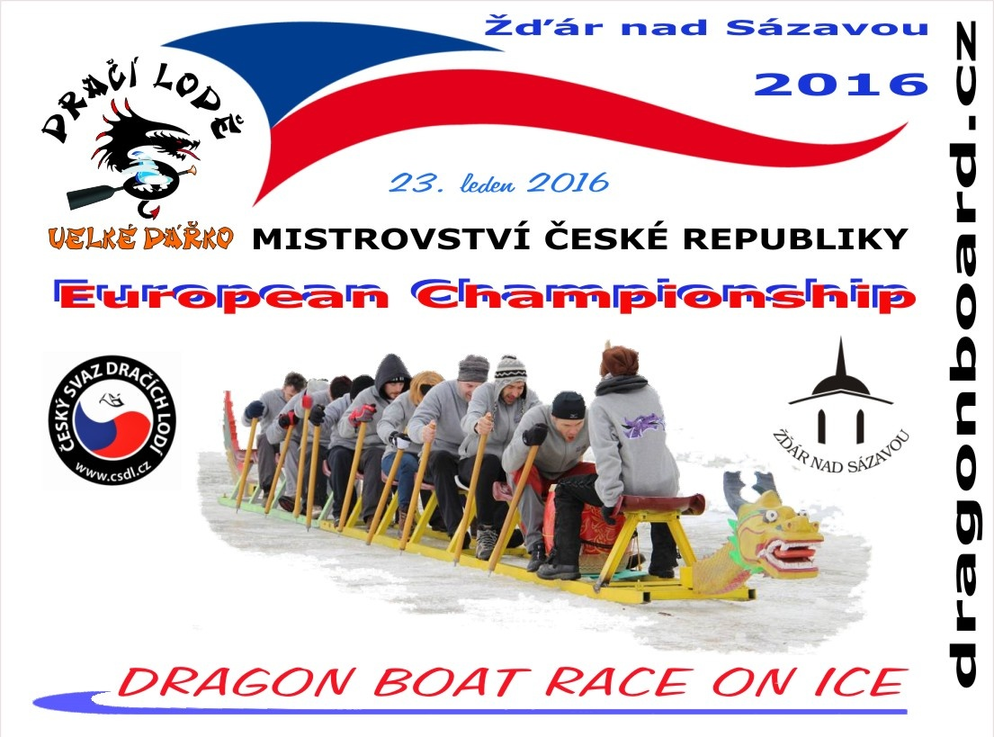
Please accept our invitation to

the 3rd year of the unique race in the Europe and World, except China

2nd Czech Republic Championships
1st European Championships

of amateur crews

at Winter Stadium - speedskating oval

in Ždár nad Sázavou

VYSOČINA DRAGONBOAT RACE SERIAL 2016

23rd January DRAGON BOAT RACE ON ICE Žďár nad Sázavou
10th June Dragon Pilák Žďár nad Sázavou Pilák (to be confirmed)
18th June Rybník Řeka Dragon boats - Mikuláš Střela trophy
30th July Dragons in Telč - Štěpnický rybník
20th August Dragon boats Velké Dářko 10th year of Žďár nad Sázavou Pilák
10th September Dragon boats Horní Cerekev the second half of the race after dark

22nd October Winning ceremony VYSOČINA DRAGONBOAT RACE SERIAL
Škrdlovice Hotel U Hrocha

VYSOČINA DRAGON BOATS are supported by Czech Dragon Boat Union www.csdl.cz

DRAGON BOAT RACE ON ICE 2016

DRAGON SLEDGE race information /program/conditions/entry fee/
3rd year DRAGON BOAT RACE ON ICE Saturday 23rd January 2016.

Alternative date: 13th February 2016 (only in case of „bad“ weather)

Race program

9:00 Captain´s meeting
9:30 Opening ceremony DRAGON BOAT RACE ON ICE 2016
10:00 First starts
16:00 Closing ceremony
17:00 Winning ceremony
18:00 ICE DRAGONS OLDIES PÁRTY v Party – Hroch´s tent

Divisions team = 10 " paddlers " + drummer 1 DRAGON SLEDGE = 11 persons

ICE DRAGONS - FUN MIX 2 women minimum + drummer

ICE DRAGONS – Women
ICE DRAGONS – Companies minimum 2 women in the team + drummer

Entry fee
ICE DRAGONS - FUN MIX / Women paid by 20t December 2015 3.000,- CZK / 120 €
by 15th January 2016 is the price 3.500,- CZK / 140 €
On the day of the race 4.000,- CZK / 160 €

ICE DRAGONS – COMPANIES paid by 20th 2015 6.000,- CZK / 240 € after this date 15th January is the price 7.000,- CZK / 280 €
On the day of the race 8.000,- CZK / 320 €

Account number

IBAN: CZ81 0300 0000 0002 1592 1309
BIC (SWIFT) kód: CEKOCZPP
Payment reference for the foreign crews - 1602

Please note the name of the team in the payment reference
Payment can be made in cash as well.

Race entry deadline 15th January 2016

In case of failure to execute the race because of bad weather as well as on the alternative date, the entry fee will be refunded, minus non-refundable 500 CZK / 20 € for the necessary preparation expenses.
In case of the crew withdrawal, the entry fee will be transferred for the summer race Pilska nádrž, minus non-refundable 500 CZK / 20 € for the necessary preparation expenses! If the crew does not participate in the winter or the summer race, the entry fee will not be refunded.
Prizes for the first three winning crews in each category
Diplomas for all crews

Additional information + entry form can be viewed at www.dragonboard.cz
Organiser´s contact:
Windsurfing Club Velké Dářko
Dragon Board Velké Dářko
Škrdlovice 95, 591 01 Žďár nad Sázavou, The Czech republic
mobile : +420 777 287 058
e-mail: info@dragonboard.cz

